(Sentiment Analysis – GCP Natural Language API)

**Software Requirements Specification**

**Document**

**Date: (04/13/2021)**

**Table of Contents**

1. Introduction 2

1.1 Purpose 2

1.2 Scope 2

1.3 Definitions, Acronyms, and Abbreviations 2

1.4 References 3

2. The Overall Description 3

2.1 Product Perspective 3

2.1.1 System Interfaces 3

2.1.2 Interfaces 3

2.1.3 Hardware Interfaces 4

2.1.4 Software Interfaces 4

2.1.5 Communications Interfaces 4

2.1.6 Memory Constraints 4

2.1.7 Operations 5

2.1.8 Site Adaptation Requirements 5

# 1. Introduction

**1.1 Purpose**

To carry out sentiment analysis on a particular topic of interest to State/FLDS and gauge the mood of public/media. You can extract information about people, places, and events, and better understand social media sentiment and customer conversations.

**1.2 Scope**

Natural Language uses machine learning to reveal the structure and meaning of text. You can extract information about people, places, and events, and better understand social media sentiment and customer conversations. Natural Language enables you to analyze text and integrate it with your document storage on Cloud Storage.

The powerful pre-trained models of the [Natural Language API](https://cloud.google.com/natural-language/docs/quickstarts) empowers developers to easily apply natural language understanding (NLU) to their applications with features including sentiment analysis, entity analysis, entity sentiment analysis, content classification, and syntax analysis.

**1.3 Definitions, Acronyms and Abbreviations**

GCP : Google Cloud Platform

NLP : Natural Language Processing

VM : Virtual Machine

JSON : JavaScript Object Notation

BERT : Bidirectional Encoder Representations from Transformers

API : Application programming interface

**Polarity** : if the speaker expresses a positive, negative or neutral opinion

**Subject** : the thing that is being talked about

**Opinion holder** : the person, or entity that expresses the opinion.

**1.4 References**

Google NLP API documentation :

<https://cloud.google.com/natural-language/docs/reference/rest>

Use cases :

[Actionable AI insights using Translation and Natural Language (Cloud Next '19)](https://www.youtube.com/watch?v=ajmWGxAr9Wk&t=2047s)

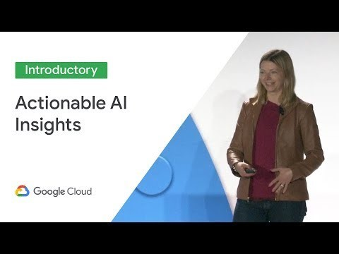

Google NLP API pricing :

<https://cloud.google.com/natural-language/pricing>

Google NLP API getting started :

<https://cloud.google.com/natural-language/docs/quickstarts>

How google does search BERT :

<https://blog.google/products/search/search-language-understanding-bert/>

BERT opensource :

<https://ai.googleblog.com/2018/11/open-sourcing-bert-state-of-art-pre.html>

Sentiment Analysis tutorial :

<https://cloud.google.com/natural-language/docs/sentiment-tutorial>

**2.0 STEPS TO GET NLP API KEY**

* Create project

* Create service account

* Service account name and access

* Enable Natural Language API

- Click on Email

* Add Key

* Get JSON

